Question 1
Create a line chart to visualize the performance trend of employees over time. Include a legend and labels.
Dataset: Employee Performance
Employee ID | Department | Years of Service | Performance Score
1 | Sales | 5 | 85
2 | HR | 3 | 92
3 | Marketing | 7 | 78
4 | Sales | 4 | 90
5 | HR | 2 | 76

Answer:
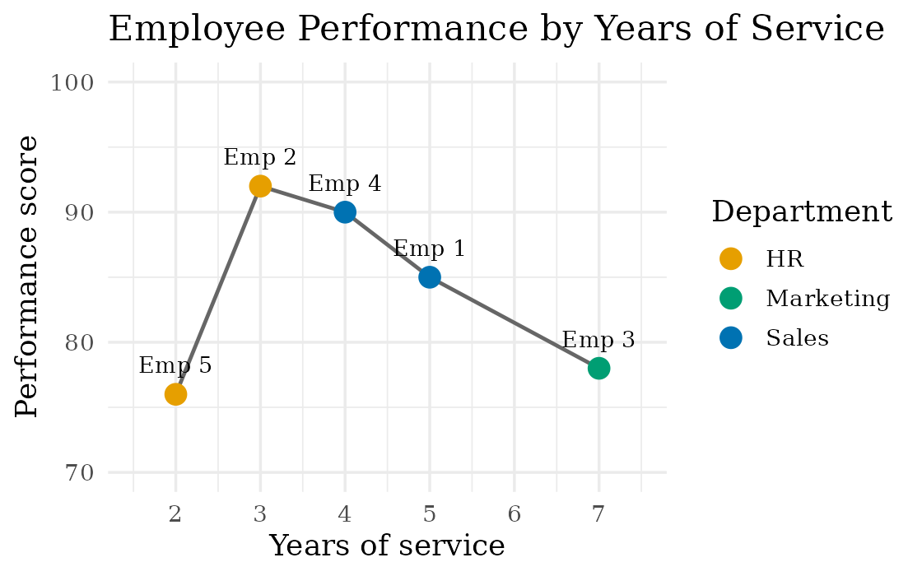
How it was built: the dataset has no dates, so Years of Service is used as the time axis and the employees are joined in order of service (2, 3, 4, 5, 7 years). Each point is labelled with its employee, the legend shows the department colours, and the chart has a title and axis labels.
Trend: performance jumps from 76 (Emp 5, 2 years) to 92 (Emp 2, 3 years), which is the peak, and then falls steadily: 90 (4 years), 85 (5 years) and 78 (7 years). The scores therefore rise early in service and decline afterwards (an inverted U); the average score is 84.2. Each employee has only one score, so the line joins different employees and is not one person's history; a true trend would need yearly scores for each employee.
R code:
library(ggplot2)
emp <- data.frame(ID = 1:5, Department = c("Sales", "HR", "Marketing", "Sales", "HR"),
Years = c(5, 3, 7, 4, 2), Score = c(85, 92, 78, 90, 76))
pal <- c(Sales = "#0072B2", HR = "#E69F00", Marketing = "#009E73")

emp <- emp[order(emp$Years), ] # order employees by years of service (time axis)

ggplot(emp, aes(x = Years, y = Score)) +
geom_line(colour = "grey40", linewidth = 0.8) +
geom_point(aes(colour = Department), size = 4) +
geom_text(aes(label = paste("Emp", ID)), vjust = -1.3, size = 3.5, family = "serif") +
scale_colour_manual(values = pal) +
scale_x_continuous(breaks = 2:7, limits = c(1.5, 7.5)) +
ylim(70, 100) +
labs(title = "Employee Performance by Years of Service",
x = "Years of service", y = "Performance score", colour = "Department") +
theme_minimal(base_family = "serif", base_size = 13)
In Tableau: Columns = Years of Service, Rows = Performance Score, Marks = Line, Color = Department (legend), Label = Employee ID.
Question 2
Generate a bar chart showing the distribution of employees across different departments. Label the chart elements.
Dataset: Employee Performance
Employee ID | Department | Years of Service | Performance Score
1 | Sales | 5 | 85
2 | HR | 3 | 92
3 | Marketing | 7 | 78
4 | Sales | 4 | 90
5 | HR | 2 | 76

Answer:
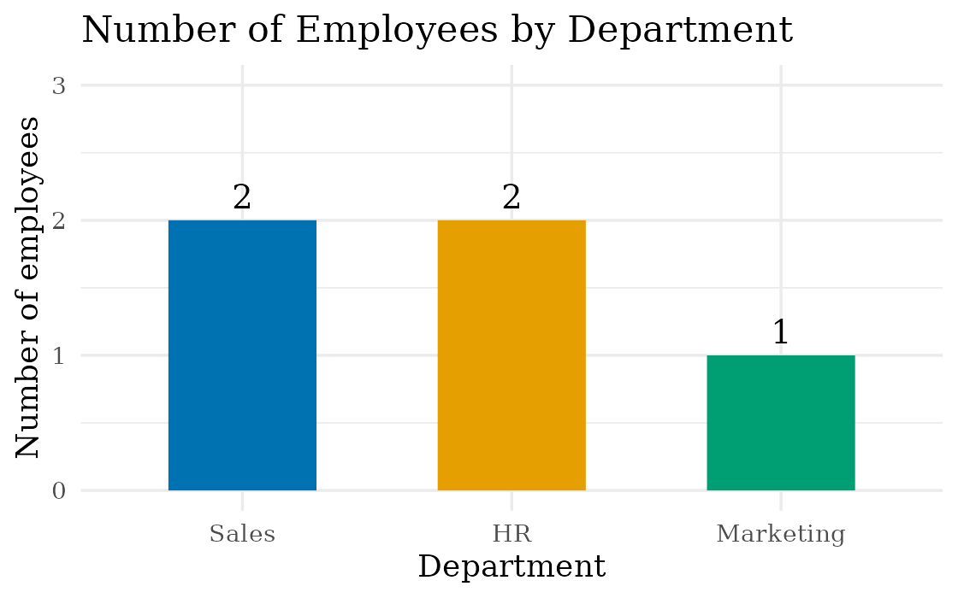
Labelled elements: title ("Number of Employees by Department"), x-axis (Department), y-axis (Number of employees), the count printed above each bar, and one colour per department.
Distribution: Sales has 2 employees (40%), HR has 2 (40%) and Marketing has 1 (20%), out of 5 employees in total. Marketing is the smallest department. For reference, the average performance score is 87.5 for Sales, 84.0 for HR and 78.0 for Marketing, but with only 1 to 2 employees per department these averages are not reliable.
R code:
# uses the data frame emp and the palette pal from Question 1
dept <- as.data.frame(table(emp$Department))
names(dept) <- c("Department", "Employees")
dept$Department <- factor(dept$Department, levels = c("Sales", "HR", "Marketing"))

ggplot(dept, aes(x = Department, y = Employees, fill = Department)) +
geom_col(width = 0.55) +
geom_text(aes(label = Employees), vjust = -0.5, size = 5, family = "serif") +
scale_fill_manual(values = pal) +
scale_y_continuous(breaks = 0:3, limits = c(0, 3)) +
labs(title = "Number of Employees by Department",
x = "Department", y = "Number of employees") +
theme_minimal(base_family = "serif", base_size = 13) +
theme(legend.position = "none")
In Tableau: Columns = Department, Rows = CNT(Employee ID), Color = Department, Label = CNT(Employee ID), sorted in descending order.
Question 3
Build a scatter plot to analyze the correlation between years of service and performance scores. Explain any insights.
Dataset: Employee Performance
Employee ID | Department | Years of Service | Performance Score
1 | Sales | 5 | 85
2 | HR | 3 | 92
3 | Marketing | 7 | 78
4 | Sales | 4 | 90
5 | HR | 2 | 76

Answer:
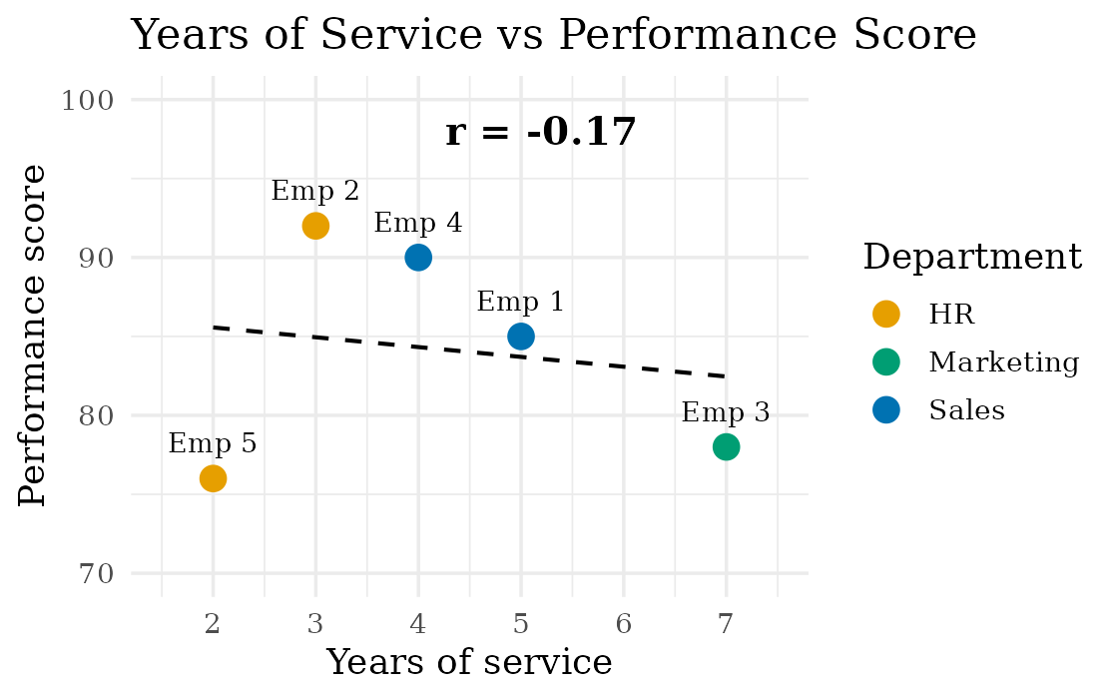
Correlation: r = -0.17 (r squared = 0.028). The trend line is Score = 86.8 - 0.62 x Years, so the score changes by only about -0.6 points per extra year. This is a very weak negative correlation, and with n = 5 it is not statistically significant (p = 0.79).
Insights:
1. There is practically no straight-line relationship: years of service explain only 2.8% of the variation in performance score, so longer service does not mean a higher (or lower) score.
2. The points are curved rather than linear: the best scores are at 3 and 4 years (92 and 90) and the lowest are at the two ends, 2 years (76) and 7 years (78). A curved (inverted U) fit explains about 69% of the variation, against 2.8% for the straight line, so the weak r hides a real pattern.
3. Tenure is not the only factor: the two HR employees have very different scores (92 at 3 years, 76 at 2 years), while Sales employees stay at 85 to 90.
4. Caution: only 5 employees were observed, and correlation does not prove cause, so more data is needed before drawing a conclusion.
R code:
# uses the data frame emp and the palette pal from Question 1
r <- round(cor(emp$Years, emp$Score), 2) # correlation coefficient

ggplot(emp, aes(x = Years, y = Score)) +
geom_smooth(method = "lm", se = FALSE, colour = "black", linetype = "dashed", linewidth = 0.7) +
geom_point(aes(colour = Department), size = 4) +
geom_text(aes(label = paste("Emp", ID)), vjust = -1.3, size = 3.5, family = "serif") +
annotate("text", x = 5.2, y = 98, label = paste("r =", r), fontface = "bold", size = 5, family = "serif") +
scale_colour_manual(values = pal) +
scale_x_continuous(breaks = 2:7, limits = c(1.5, 7.5)) +
ylim(70, 100) +
labs(title = "Years of Service vs Performance Score",
x = "Years of service", y = "Performance score", colour = "Department") +
theme_minimal(base_family = "serif", base_size = 13)
In Tableau: Columns = Years of Service, Rows = Performance Score (both as Dimension/Continuous with each Employee ID as a mark), Color = Department, then Analytics > Trend Line.
Question 4
Develop a Tableau dashboard with the line chart and bar chart for interactive exploration.
Answer: steps to build the dashboard in Tableau
1. Connect to the data. Save the table as Employee_Performance.xlsx (Employee ID, Department, Years of Service, Performance Score), then choose Connect > Microsoft Excel and drag the sheet in. Right-click Employee ID and choose Convert to Dimension so it is not summed.
2. Sheet 1, "Performance Trend" (line chart). Columns = Years of Service (Continuous), Rows = AVG(Performance Score), Marks = Line, drag Department to Color (this creates the legend) and Employee ID to Label. Marketing has one employee, so make the second Performance Score a dual axis with Circle marks so that its single point shows. Add a title and axis titles.
3. Sheet 2, "Employees by Department" (bar chart). Columns = Department, Rows = CNT(Employee ID), Color = Department, Label = CNT(Employee ID), sort descending, and add a title and axis titles.
4. Create the dashboard. Click New Dashboard, drag "Performance Trend" to the top and "Employees by Department" below it, show the Department colour legend, and add a title text object: "Employee Performance Dashboard".
5. Add interactivity. (a) Select the bar chart and click Use as Filter (funnel icon): clicking a department bar then filters the line chart to that department. (b) Dashboard > Actions > Add Action > Highlight (Source: bar chart, Target: line chart, Field: Department) to highlight on hover. (c) On Sheet 1 add the filters Department and Years of Service, choose Show Filter, and apply them to both worksheets. (d) Edit the tooltips to show Employee ID, Department, Years of Service and Performance Score.
6. Save the work as a packaged workbook (.twbx) or publish it with File > Save to Tableau Public.
Dashboard layout (sketch):
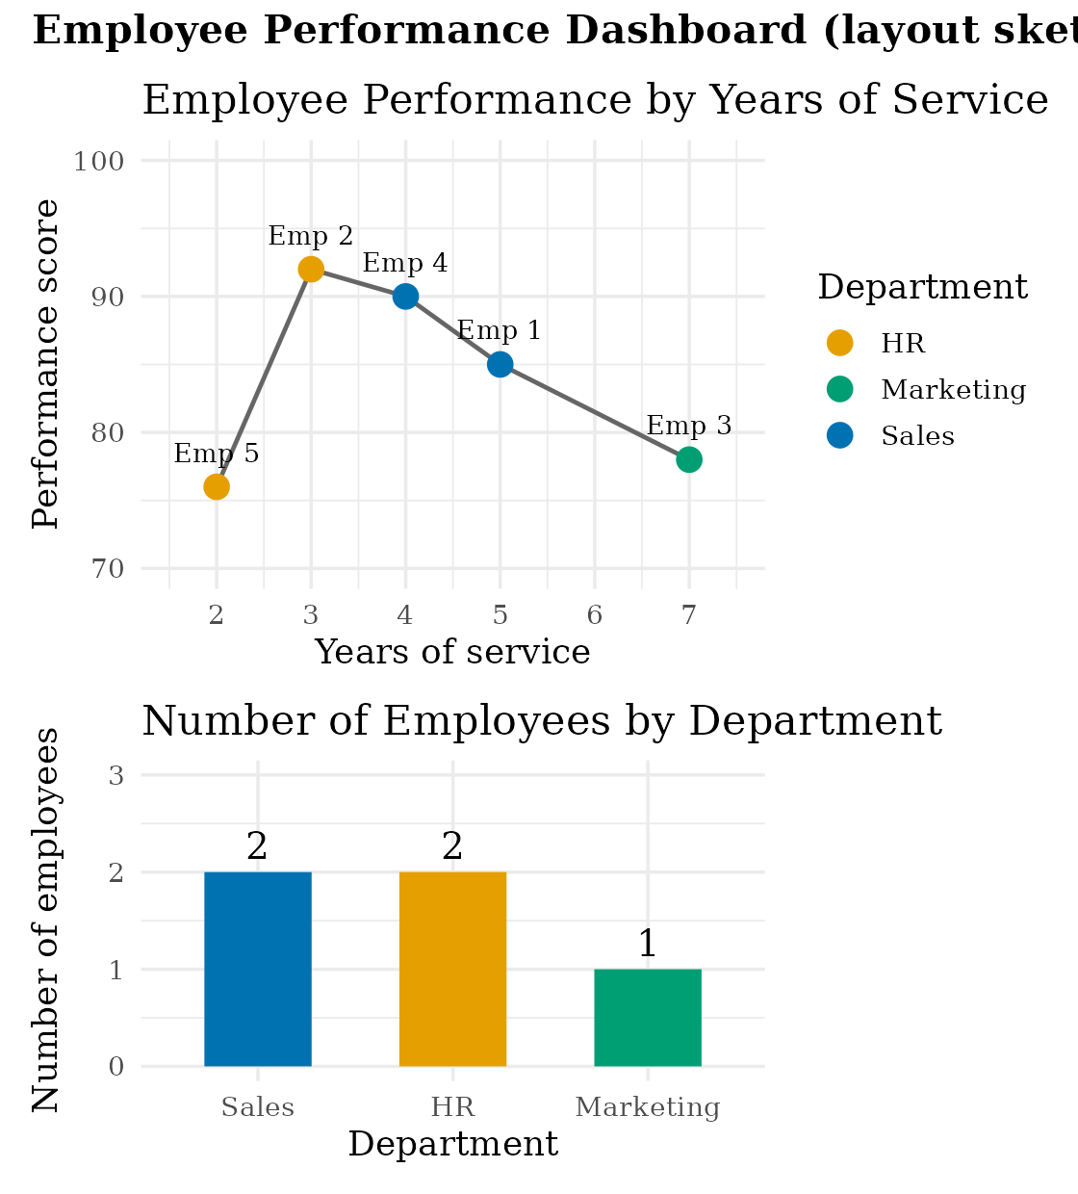
Interaction: clicking the Sales bar leaves only Emp 1 and Emp 4 in the line chart; clearing the selection (or clicking an empty area) shows all five employees again.

